Nested and multilevel if elsif statements

1) Write a program to output different messages when number is:

a. Greater than 3

b. Lesser than 3

c. Or equal to 3

d. Or when the user input is empty

multi.sh

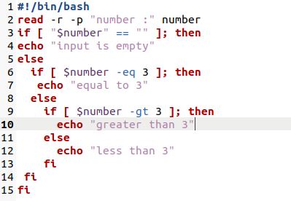

Terminal

